Making Cycling Safer
Leeds Cycling Campaign was at Gledhow Valley Green Fair on Sunday 12th July.
We asked people who cycle, or would like to cycle more, what is needed to make cycling safer. Below are some of the things they said were important to them. We highlight key priorities for action on page 3

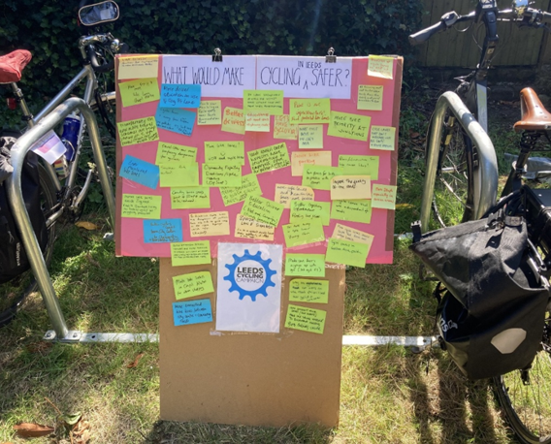

- Improvements to cycling lanes
People generally are pleased to see more cycle lanes and have several ideas about how these could be improved to make cycling safer:
- Be more connected up

- Be better maintained (e.g. without potholes, gravel or broken glass)

- Have better signage on and around cycle lanes

- ‘paint is not infrastructure’, have more protected / segregated cycle lanes
Some specific issues included the DANGER of:
- Bi-directional cycle lanes and junctions (e.g. Dewsbury Rd). Drivers don’t look both ways: better signage all round especially for drivers

- Items placed on cycle lanes (e.g. roadwork, or lane closure related). One cyclist described being thrown from his bike riding in the dark as he hit metal fencing put in the bike lane in Headingley

- Improving the quality of roads and road repair /improvement practices

- Improve the quality of road surfacing; repair potholes

- Road surface dressing is hazardous for cyclists, making roads slippery (e.g. Weardley Bank late spring 2026). The dressing ‘gathers’ making junctions more dangerous for cyclists (e.g. Five Lane Ends late spring 2026)

- Educating drivers and reducing driving speeds

- Do more to educate all road users; wider driver education is needed, campaign to promote awareness of the Highway Code hierarchy of road users

- More specific driver education – e.g. on Clay Pit Lane (= signage)

- Reduce speed limits (e.g. especially on out of town / country roads)

- Cycle paths – specific asks
- More bike priority at junctions

- Stop parking on/blocking cycle lanes [multiple examples including Arndale Centre, LS6; stop car parking on cycle path near Accommodation Rd

- Improve cycle paths outside Ring Road eg Bramhope to Otley; Cycle lanes to Golden Acre Park; Cycle lanes around and on Scott Hall road; from City Centre to University, more in LS7 and LS8 areas; and on A58, old ring road to Seacroft; Link up Roundhay park cycle track and ELOR.

- Better integration needed between highways and active travel

- Improved cycle parking

- People were very pleased to hear about the new cycle hangars in the city centre and wanted more in the suburbs

We summarise priorities overleaf

Proposals to Leeds City Council and partners
Immediate short term actions
- Maintaining bike lanes: keeping them clear of obstacles, clear of parking and vehicles dropping off, clear of broken glass and in a good state of repair. Who has responsibility for this, and for enforcing clear passage, and how can issues be reported and addressed?

- Ensure a precautionary principle when bike lanes are closed to cyclists: use plastic and not metal barriers, ensure visible signage and hazard warnings (example of accident near St Michael’s Church/ Headingley northbound cycle lane.

- Improve safety at dangerous junctions (better signage). What progress is being made at Clay Pit Lane junction given our longstanding concerns?

- When surface dressing is considered / used for road repairs, how can we ensure that the safety of cyclists is addressed?

We additionally seek further actions in the short to medium term as follows:
- Improve road layout and signage at dangerous junctions;

- Improve driver awareness of the Highway Code hierarchy of road users

- Get more feedback from cyclists on the connectedness of Leeds cycling infrastructure to inform priorities.

Leeds Cycling Campaign,
22 July 2026.

